**APPLICATION DOCUMENT**

**Task Manager (Portal)**

**Prerequisites :**

1. PHP 5.7 or above
2. WAMP
3. Text Editor
4. Browser (Latest Version)

**LOGIN (Flow Chart) :**

**Admin User**

The common page for admins looks like this :

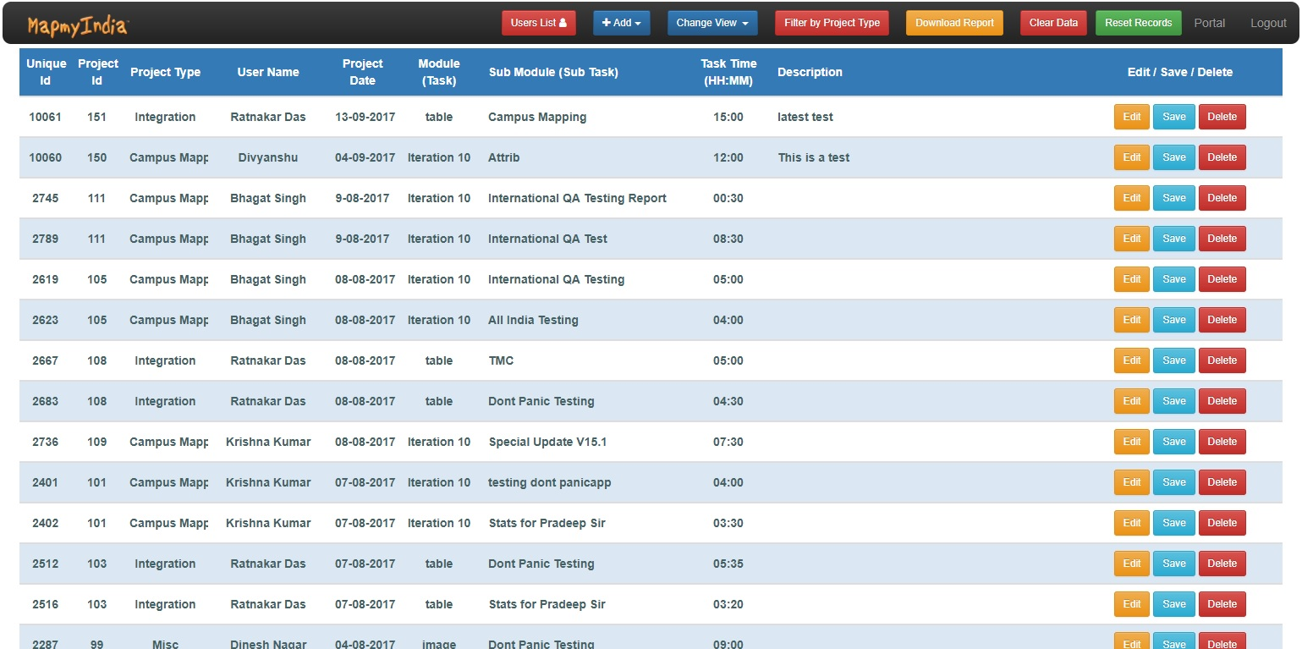

It consists of 10 columns following

1. **Unique ID :** Contains the Task ID.
2. **Project ID :** Contains the Project ID.
3. **Project Type :** Which Project type does the task belong to.
4. **User Name :** Name of the user who worked on this task.
5. **Project Date :** Date on which the task was done.
6. **Module :** Module to which does the task belong to
7. **Sub Module**
8. **Task Time**
9. **Description**
10. **EDIT/SAVE/DELETE**

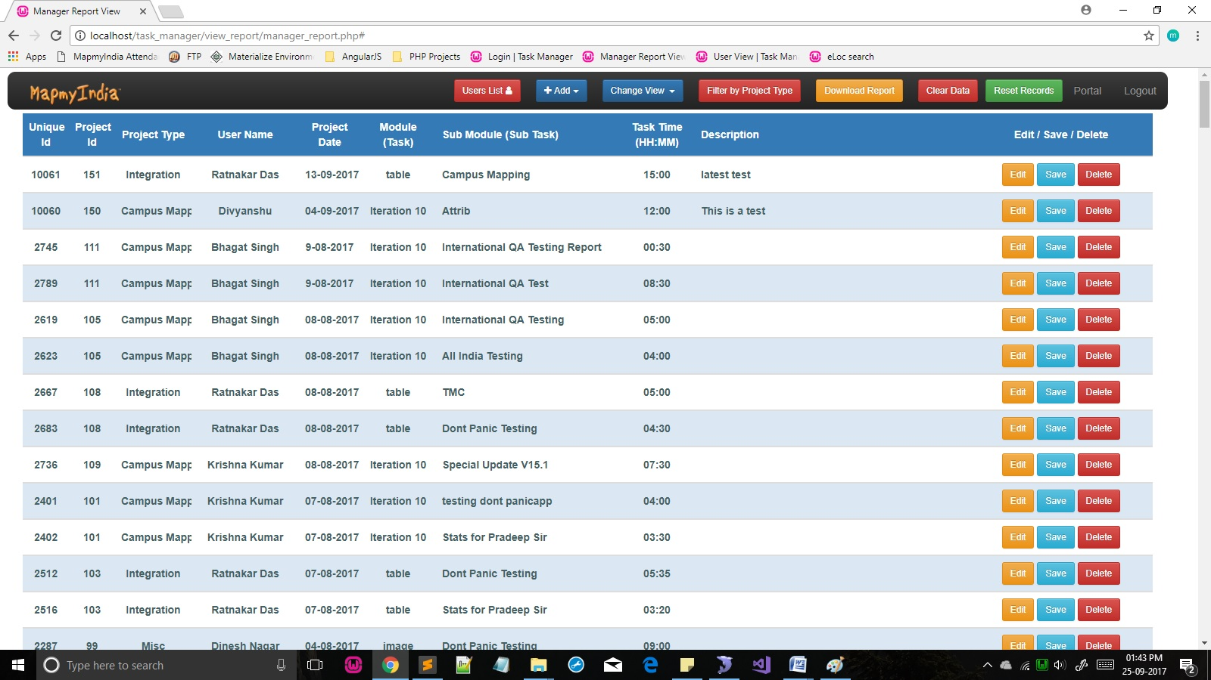

**Following options are available in the Navbar :**

1. **Users List**

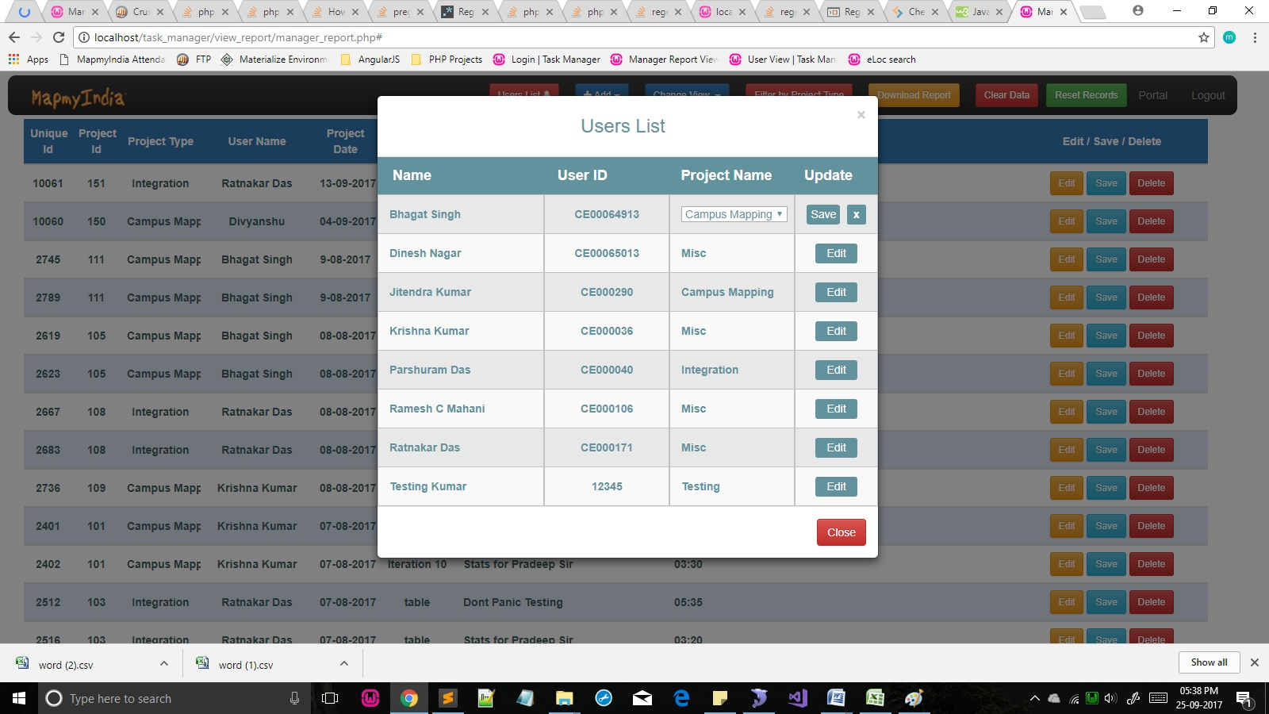This button opens up a modal which represents a list of all the users present along with their respective User IDs and the projects they are linked to. Also, it gives an option to edit the project every user is associated with.

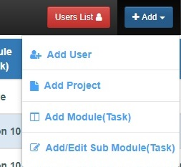

1. **+ Add**

This is a dropdown button which gives the admin options to add various entities :

* 1. **Add User**
  2. **Add Project**
  3. **Add Modules**
  4. **Add/Edit Sub Modules**

1. **Add User**

This option allows the admin to add user(s) of type ‘0’. It opens a modal which asks for basic information like **User ID,** **Name and Project Type** about the new user being added. There is also an option to add multiple users at a time. For multiple entries, click **+ add more** button. Fill in all the fields and click submit to add the users. Unwanted rows can be deleted by clicking the **Bin** icon next to each row.

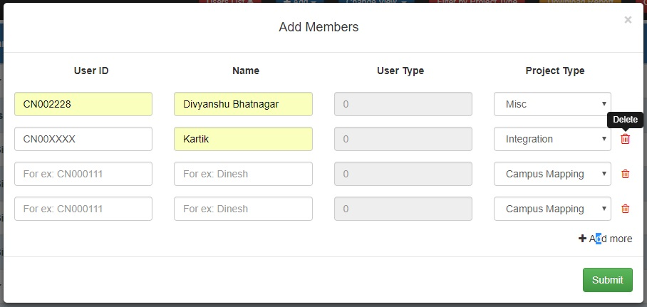

1. **Add Project (CYCLE)**

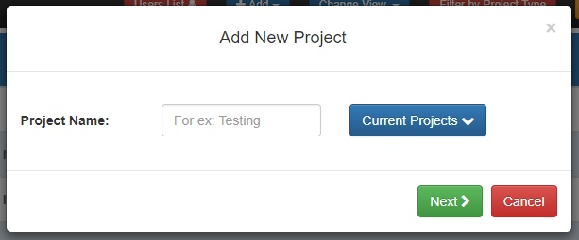This option allows the admin to add a **New Project**. It consists of a single field that is Project Name. Also, it has a dropdown which, on hover, shows up the current projects present in the database.

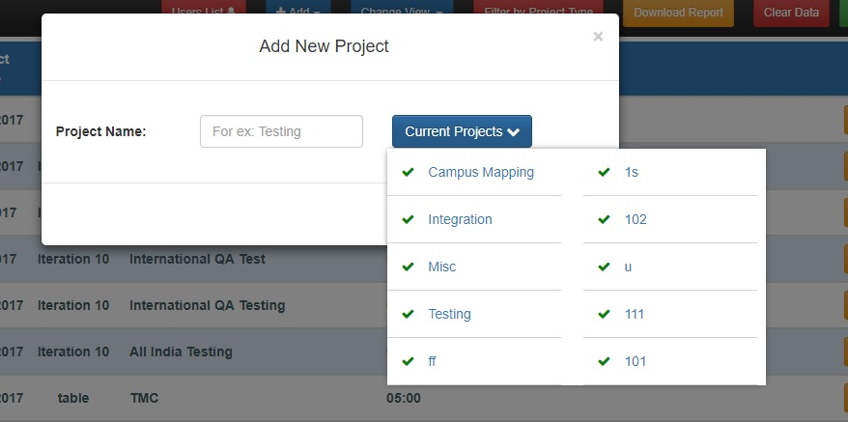

Also, this modal gives the user an opportunity to create a **New Project, Modules and Sub Modules** in a cycle. On clicking the next button, another modal opens up which adds **Sub Modules.** In this modal, there are two fields, name of the sub module and a dropdown of projects where the project created in this cycle is already selected. It also supports multiple entries. Multiple rows may be added using **+ Add more** button and deleted using the bin icon.

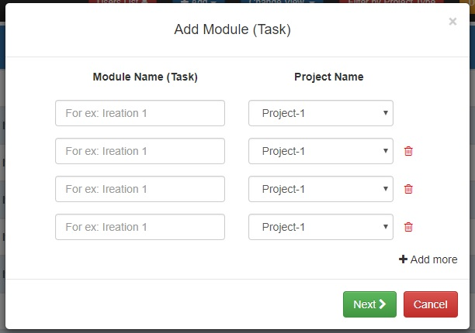

On clicking the next button, the cycle continues further to **Sub Modules Modal.** This modal has two fields, name of the sub task and projects dropdown. The project created in the cycle is already selected in the dropdown. The user can add multiple sub modules to the project by adding more rows using **+ Add more** button and delete using the bin icon next to each row. On clicking **Done,** the cycle gets completed and the user gets a message about the same.

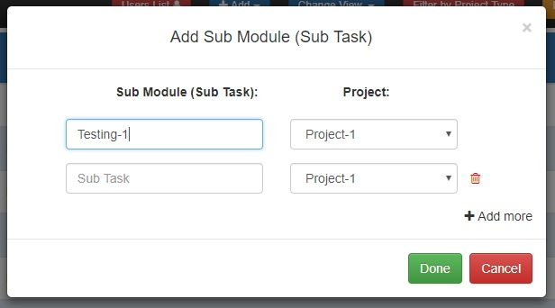

**NOTE :** If the user chooses to cancel anytime during the cycle, the cycle halts down and the process until that modal is completed.

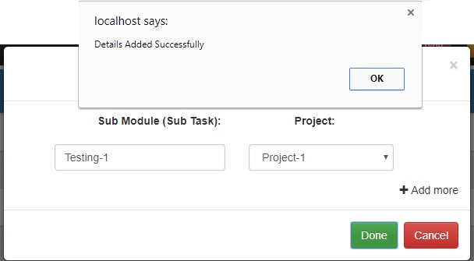

1. **Add Module (Task)**

This buttons allows the user to add **Modules.** It opens a model which asks for a Module name and has an option to select the Project to which the module has to be added. Also, the user may add multiple Modules by adding more fields which can further be deleted using the bin next to each row.



**On success, a confirmation modal opens up telling the number of entries made where as on error, a modal opens with the cause of the failure.** 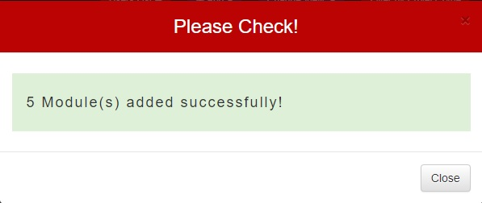

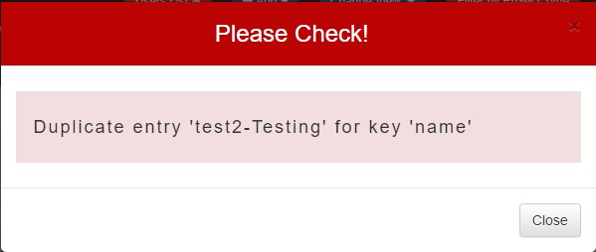

1. **Add / Edit Sub Module**

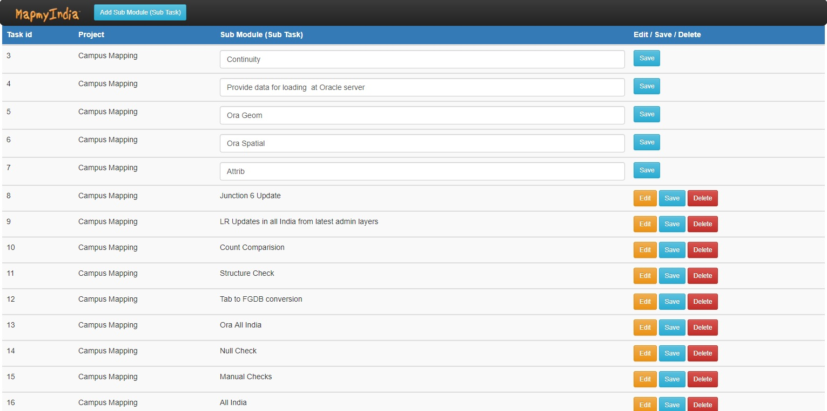This link takes the user to a new page where the user can view, add, delete and update the sub modules. On clicking Edit button, the Sub Module’s name becomes editable which can be edited and saved.

* + 1. **Add/Edit Sub Module Button**

It opens a model which asks for a Module name and has an option to select the Project to which the module has to be added. Also, the user may add multiple Modules by adding more fields which can further be deleted using the bin next to each row.



1. 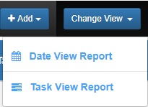**Change View**

This button allows the user to view the details ordered on the basis of two different criteria’s. They both take the user to a new page.

* 1. **Date View**
  2. **Tasks View**

1. **Date View**

This structure of this view is based on Date on which the projects were created. The basic idea is to show working duration of employees for a particular object on a particular date. An employee with no working duration in a project has ‘**0**’ written in his column where others have their respective durations. In the end lies a row which indicates the number of **Days** and total working duration of each user.

**It consists of various columns** :

* + 1. **ID**
    2. **Task**
    3. **Project**
    4. **Employees’ Name**

Date View Navbar.jpg

Its navbar has various **buttons** :

* **Tasks View**

This is a link to another page which has a structure based on the Projects.

* **Filter by Date**

This functionality allows the user to **Filter the results** on the basis of the **Date** they were created on. The user is given a calendar to choose a range of dates as per his choice to get the results based on his requirements.

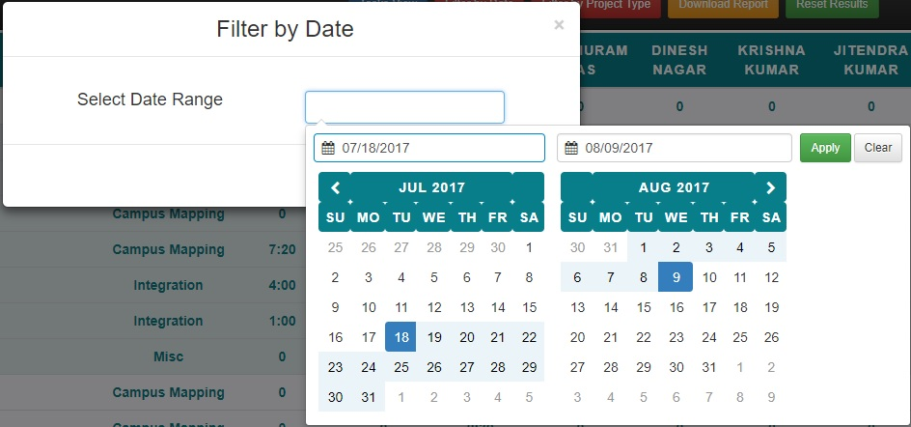

On applying, the results shown on the page are filtered on the basis of the date range selected by the user. Also, the last row changes as per the filtered records.

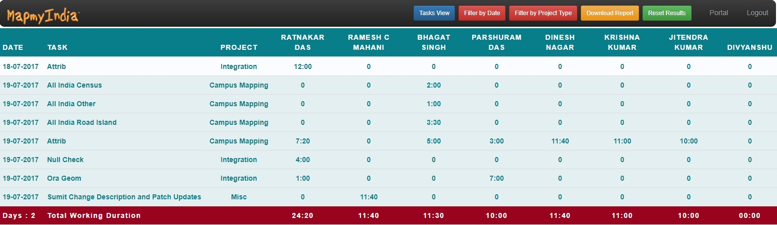

However, if the user chooses a date range in which no records were found, there is a simple message shown to the user about the same.

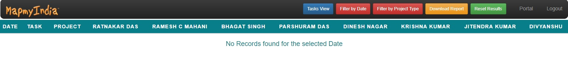

* **Filter by Project**

This functionality allows the user to **Filter the records** on the basis of the **Projects**. The user is given a checklist where he can choose the projects which he wants details of.

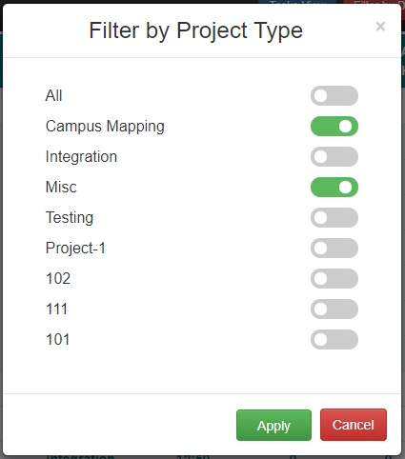

On applying, the results shown are filtered on the basis of **Projects** chosen by the user. Also, the last row on the page updates the total working days and working duration of each user.

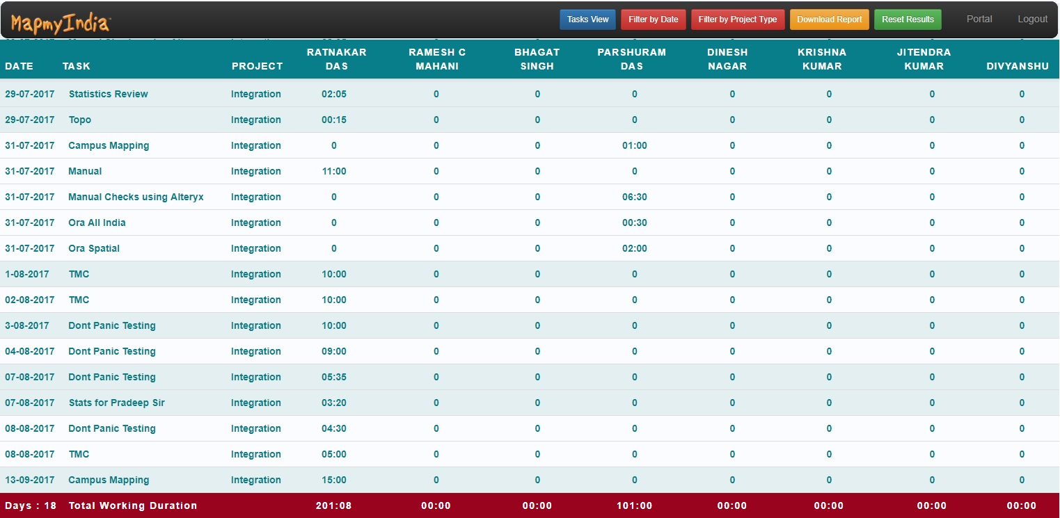

* **Download Report**

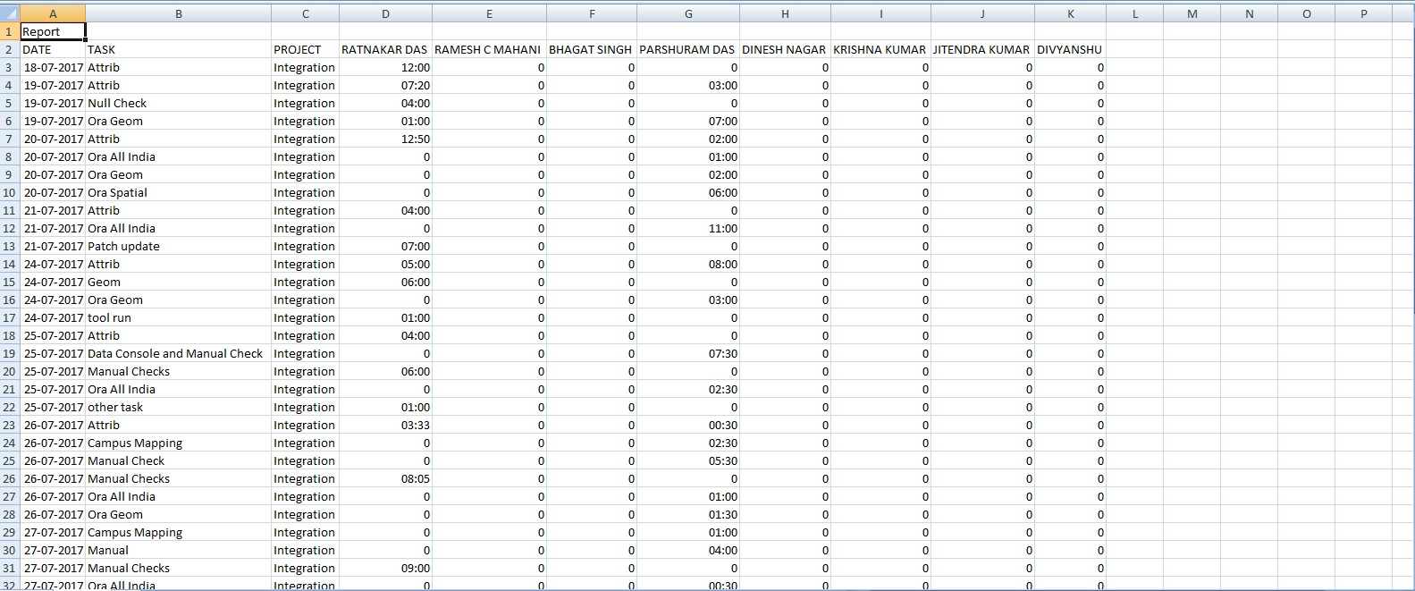The current records being shown can also be downloaded using this button. It downloads the records shown, i.e., either filtered or original, as a **CSV Document**.

* **Reset Results**

This button is used to Reset the records being shown. This has been added merely for the user’s convenience, i.e., if a user has filtered results and wants to go back to original results.

* **Portal**

This link is used to go to Portal page.

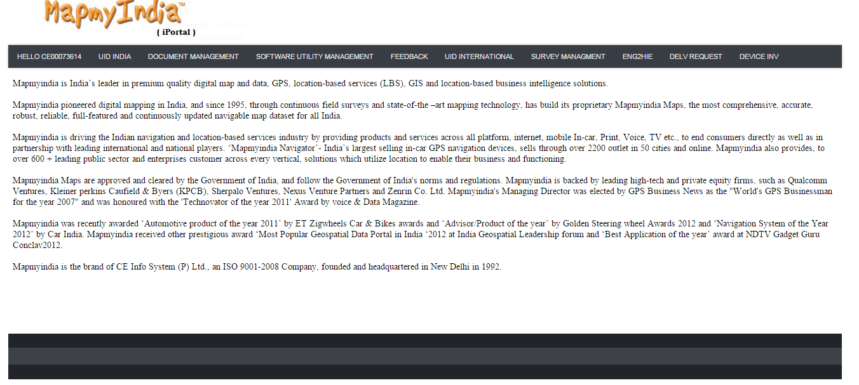

* **Logout**

This link is used to log out a user. Also, it brings back user to the Portal page.

1. **Task View**

This is another type of view where the records are structured on the basis of **Tasks.**  It consists of various columns :

1. **ID**
2. **Task**
3. **Project**
4. **Employees’ Name**
5. **Total Time for each Task**

Task View Navbar.jpg

Its Navbar has various **buttons** : -

* **Date View**

This is link to another page where records are shown structured on **Dates** the projects were created on.

* **Show Graphs**

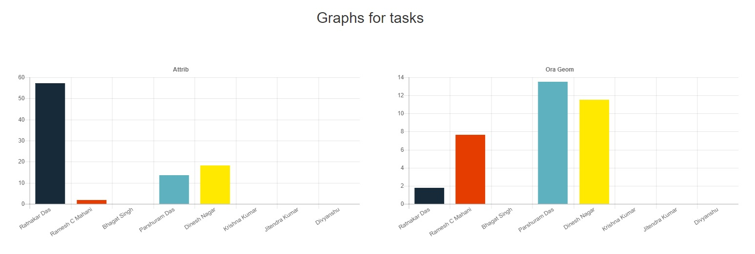This button opens up a page where the results are shown using graphs for the current result set. The graphs are shown for each task where working duration of each user is depicted with different colours.

* **Filter by Date**

This functionality allows the user to **Filter the tasks** on the basis of the **Dates** they were created on. The user is given a calendar to choose a range of dates as per his choice to get the results based on his requirements.

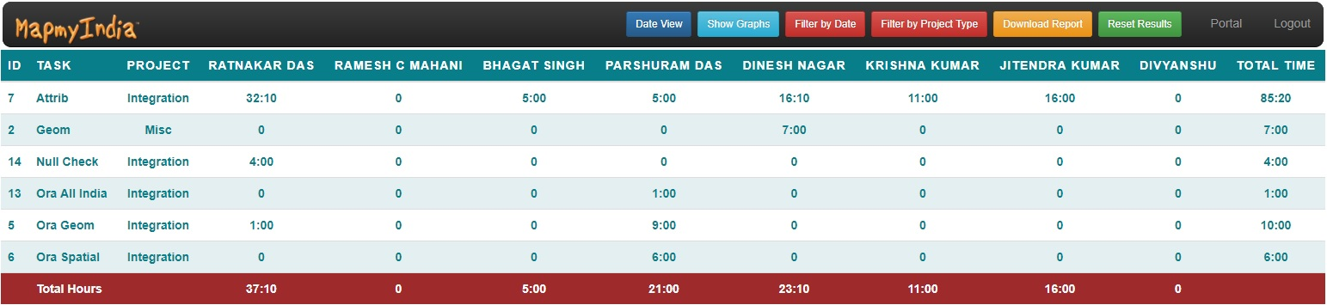 **On applying, the results shown on the page are filtered on the basis of the date range selected by the user. Also, the last row changes as per the filtered records.**

**However, if the user chooses a date range in which no records were found, there is a simple message shown to the user about the same.**

* **Filter By Projects**

This functionality allows the user to **Filter the records** on the basis of the **Projects**. The user is given a checklist where he can choose the projects which he wants details of.



On applying, the results shown are filtered on the basis of **Projects** chosen by the user. Also, the last row on the page updates the total working days and working duration of each user.

* **Download Report**

The current records being shown can also be downloaded using this button. It downloads the records shown, i.e., either filtered or original, as a **CSV Document**.

* **Reset Results**

This button is used to Reset the records being shown. This has been added merely for the user’s convenience, i.e., if a user has filtered results and wants to go back to original results.

* **Portal**

This link is used to go to Portal page.



* **Logout**

This link is used to log out a user. Also, it brings back user to the Portal page.

1. **Filter by Project**

This functionality allows the user to **Filter the records** on the basis of the **Projects**. The user is given a checklist where he can choose the projects which he wants details of.



**On applying, the results shown are filtered on the basis of Projects chosen by the user.**

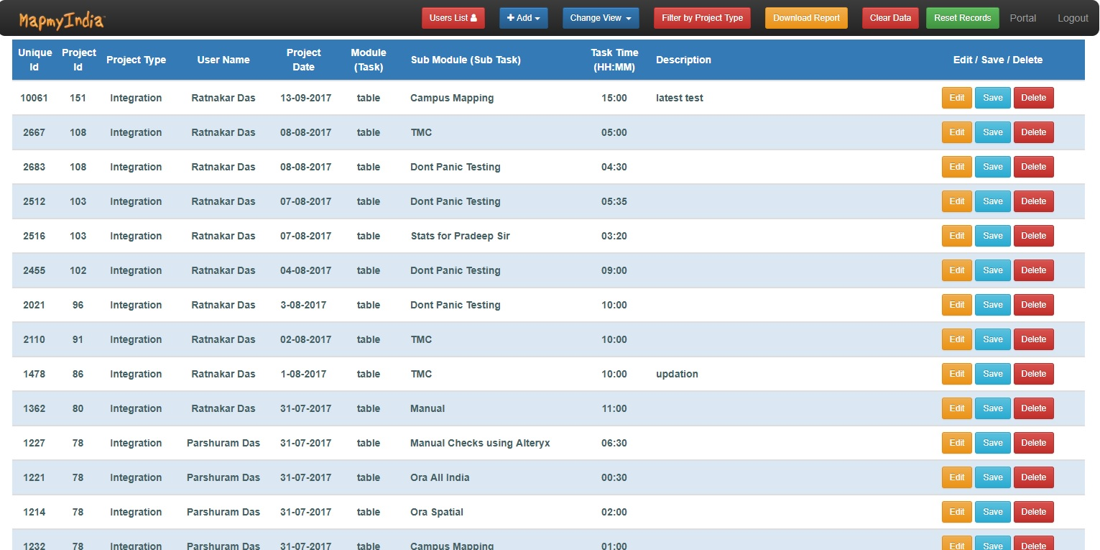

1. **Download Report**

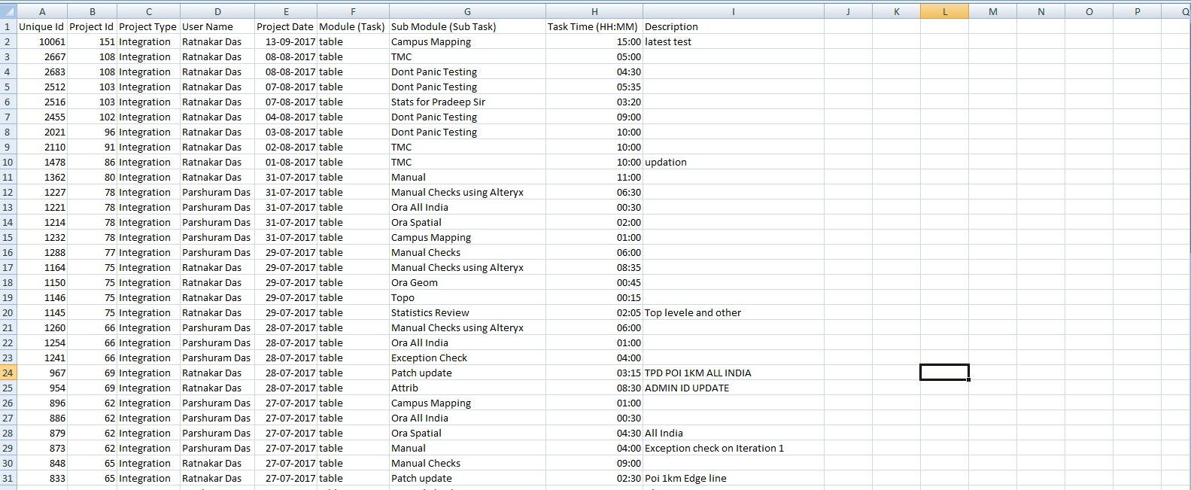The current records being shown can also be downloaded using this button. It downloads the records shown, i.e., either filtered or original, as a **CSV Document**.

1. **Clear Data**
2. **Reset Records**

This button is used to Reset the records being shown. This has been added merely for the user’s convenience, i.e., if a user has filtered results and wants to go back to original results.

1. **Portal**

This link is used to go to Portal page.

1. **Logout**

This link is used to log out a user. Also, it brings back user to the Portal page.

**Non-Admin User**

**User Navbar.jpg**

**Following options are available in the Navbar :**

1. **Portal**

This link is used to go to Portal page.

1. **Logout**

This link is used to log out a user. Also, it brings back user to the Portal page.

1. **Create Back Date Projects**

This button opens up a modal which allows the user to create a back date project. The modal has basic fields like User ID which is already filled and not editable, Date ( should be in the past ) and option to select a Module

On entering an invalid date, an alert box alerts the user about the invalid date entered.

Also, the date cannot be chosen from future.

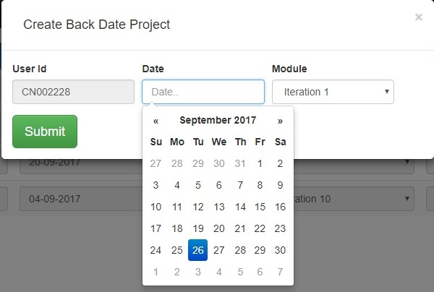

**Projects Table**

This is a common view for all the non-admin users where all the projects associated with the user are shown. Also, it has the special functionality that a project may not be altered which is more than 3 days old. All the projects more than 3 days old are disabled.

When the user clicks on the ‘**Click to add Tasks’** input box, a modal opens up with the tasks compatible with the type of user. Also, user is free to alter the tasks in the project unless the project is more than 3 days old. The user may change already filled values to update the same.

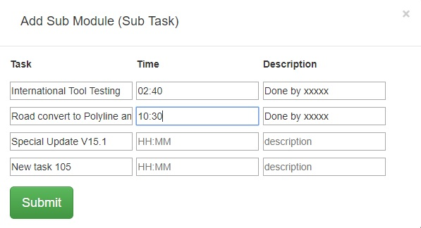

**Create New Project Button**

This button adds a row in the Projects table with today’s date being set and disabled. The user may choose the Module and Sub Module as per the requirements.

